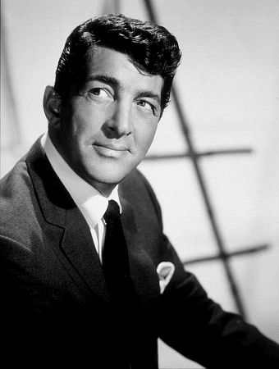
The Mixed Nuts
Set N last revised on 2016.02.07

N01-Give Me The Simple Life(KVF).2016.02.07.pdf
N01-Give Me The Simple Life(KVM).2016.02.07.pdf
N02-Missouri Waltz(KV).2014.04.07.pdf
N03-More Than You Know(KVF).2015.01.25.pdf
N03-More Than You Know(KVM).2015.01.25.pdf
N04-Hey, Good Lookin'(KVF).2014.04.19.pdf
N04-Hey, Good Lookin'(KVM).2014.04.19.pdf
N05-Linda(KV).2015.05.31.pdf
N06-All I Do Is Dream Of You(KVF).2015.01.25.pdf
N06-All I Do Is Dream Of You(KVM).2015.01.25.pdf
N07-Strangers In The Night(KVF).2015.05.10.pdf
N07-Strangers In The Night(KVM).2015.05.10.pdf
N08-Springtime Polka(K).2014.04.07.pdf
N09-Everybody Loves Somebody(KVF).2015.01.25.pdf
N09-Everybody Loves Somebody(KVM).2015.01.25.pdf
N10-Blue Moon(KVF).2014.09.19.pdf
N10-Blue Moon(KVM).2014.09.19.pdf
N11-That's Amore(KV).2015.01.25.pdf
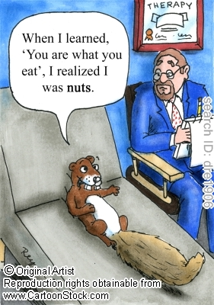
N12-In My Solitude(KVF).2015.01.25.pdf
N12-In My Solitude(KVM).2015.01.25.pdf
N13-Baby, It's Cold Outside(KV).2015.01.25.pdf
N13-Baby, It's Cold Outside(VOCAL).2015.01.25.pdf
N14-Makin' Whoopee(KVF).pdf
N14-Makin' Whoopee(KVM).pdf
N15-Somewhere, My Love(KVF).2014.04.07.pdf
N15-Somewhere, My Love(KVM).2014.04.07.pdf
N16-My Dreams Are Getting Better
All The Time(KVF).2015.01.25.pdf
N16-My Dreams Are Getting Better
All The Time(KVM).2015.01.25.pdf
N17-Seventy Six Trombones(KVF).2014.11.16.pdf
N17-Seventy Six Trombones(KVM).2014.04.07.pdf

